3D Weather in the Classroom

**2010 Nashville Floods**

**1.Overview**

Between May 1st through 2nd of 2010, Nashville, TN experienced the highest totals of rainfall it has seen in the past 140 years with rainfall measurements exceeding 17 inches. The immense amount of rainfall measured occurred in a span of two days causing the Cumberland waterway to flood areas throughout Nashville and surrounding areas resulting in over 2 billion dollars in damages and 11 fatalities. Over 30 % of Tennessee was ruled a major disaster area.

This disastrous event was able to occur due to a strong low jet dragging warm, moist air from the tropics northward. There was an immense amount of moisture through the combination of a tropical air mass from the eastern Pacific Ocean flowing westward combined with the tropical Caribbean air mass that flowed northward through the Mississippi Valley.

The flow of abundant moisture within this air mass continued between a trough over the western US and a subtropical ridge over the southeast US. This environment which included lots of moisture and warmer temperature was conducive for the development of two mesoscale convective systems (MCSs) in a span of 48 hours.

A MCS is a collective group of thunderstorms that act as one system. MCSs occur when convective clouds amalgamate and create one single cloud structure that spans over great distances and have the potential to produce copious amount of precipitation. These MCSs can cover the span of an entire state and last longer than 12 hours. Nashville experienced 2 separated MCSs within the span of 48 hours, and the rainfall produced exceeded historical accumulations within a 48-hour period.

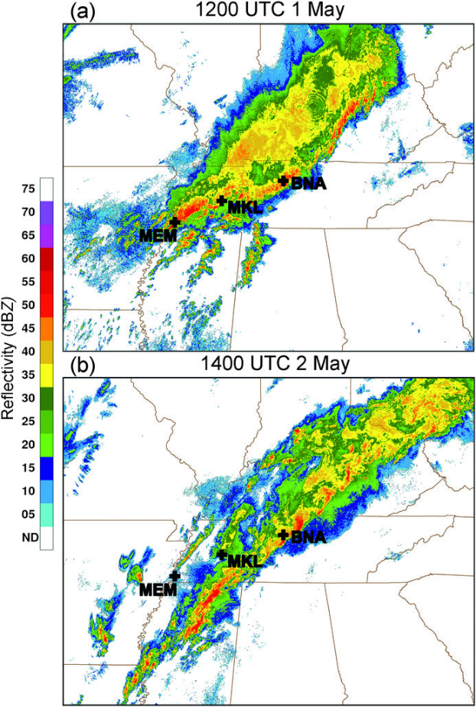

Figure 1. Radar imagery is showing both the first MCS that occurred on May 1st and the second MCS that occurred on May 2nd.

Radar imagery shows the structure of the MCSs. A feature that can be recognized on radar is how the areas around the MCSs share a cold pool (Figure 1). The cold pool is the result of the system extracting heat from the environment to sustain itself.

These MCS were able to exist not only due to the tropical air mass, but also due to the stationary ridge that exists downstream. The stationary ridge enables the heat and moisture to accumulate and produce two MCSs.

Figure 2. IDV image of 300 mb streamlines from May 1st, 2010.

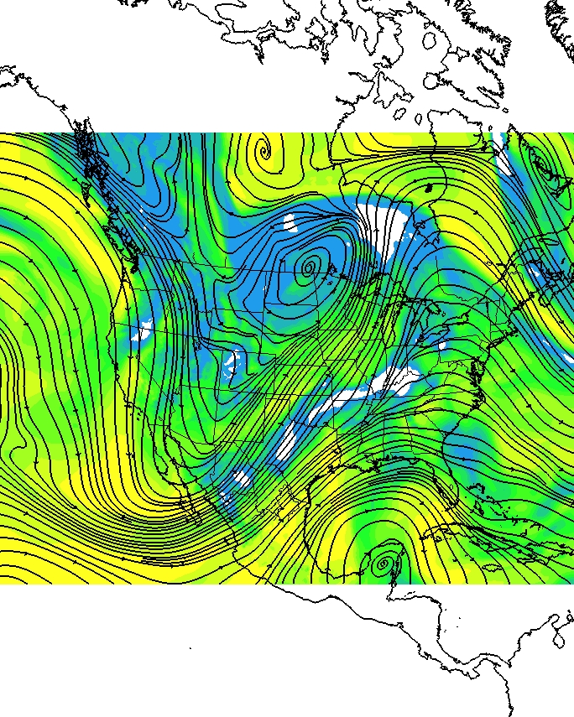

Figure3. IDV image is showing 300 mb streamlines and 700mb relative humidity from May 1st, 2010.

The stationary ridge over the western US and the trough over the far eastern US and Atlantic Ocean can be seen by observing a constant pressure surface at 300 mb (Figure 2). The southwesterly flow that carries the warm, moist air from the tropics up the Mississippi Valley can be seen by following the streamlines that originate in the Caribbean and the Pacific oceans. Relative humidity was overlaid at a constant pressure level at 700 mb (Figure 3). The air mass between the trough and the stationary ridge consisted of lots of moisture over Tennessee (Figure 3). The ingredients were present to form the MCS.

**2. IDV Project**

Project filename: “2010NashvilleFloods.xidv”

* Project data:
  + Filename: “namanl_218_20100501_1200_000.grb”
  + North American Mesoscale (NAM) model May 1st, 2021 @ 1200 UTC
  + File retrieved from NOAA operational model page for select levels and variables:
    - NOMADS-NOAA Operational Model Archive and Distribution System
* Displays:
  + Maps
    - World country outlines.
  + Plan views
    - Relative Humidity color filled contours at 700 mb
  + Flow displays
    - 300 mb streamlines
* Features to note:
  + The southwesterly flow carries warm, moist tropical air from the tropics into the Mississippi Valley enabling the formation of two MCSs.
    - The 300 mb streamlines emphasize the southwesterly flow.
    - The relative humidity contours show the moisture that was able to support the MCSs.

**3. Knowledge Requirements**

* Module 3-2: Measures of Moisture
* Module 7-1: Cold and Warm Fronts
* Module 5-1: Overview of Pressure and Wind

**4. Knowledge Test**

Question 1: True or False. Nashville experienced the most amount of rainfall it has seen in over 140 years.

* **A: True**
* B: False

Question 2: Over 30% of Tennessee was considered a disaster area due to the _______ flooding areas surrounding Nashville and up through Kentucky.

* A: **Cumberland waterway**
* B: Mississippi River
* C: Lake Martin
* D: Stone River

Question 3: The origins of the warm air mass were:

* A: the Pacific ocean
* B: the Caribbean ocean
* C: the Atlantic ocean
* **D: Both A and B**

Question 4: A single convective system that is made from smaller convective systems are referred to as:

* A: mesocyclone
* B: **mesoscale convective systems**
* C: mid-latitude cyclone
* D: hurricane

Question 5: How are cold pools recognized?

* **A: radar imagery**
* B: satellite imagery
* C: remote sensing
* D: models

Question 6: What role did moisture play for this disastrous event?

* A: abundance of moisture saturates the atmosphere and enables the formation of clouds and precipitation.

Question 7: What was the factor that enabled the moisture to accumulate over Nashville areas?

* A: shallow trough
* **B: stationary ridge**
* C: stationary trough
* D: shallow ridge

Question 8: How many inches of rainfall accumulated over the span of the 2 days?

* A: < 3 inches
* B: < 10 inches
* C: =15 inches
* **D: > 17 inches**

Question 9: MCS can cover the span of up to an entire_________ and last for longer than _____ hours.

* A: town, 5
* **B: state, 12**
* C: football field, 48
* D: city, 12

Question 10: True or False. There was only 1 MCS that occurred between May 1st and May 2nd of 2010.

* **A: True**
* B: False